A567-AM,S-Ecuador-Chorrera culture-Vessel with Eight Anthropomorphic Heads-Terra Cotta-1200-300 BCE

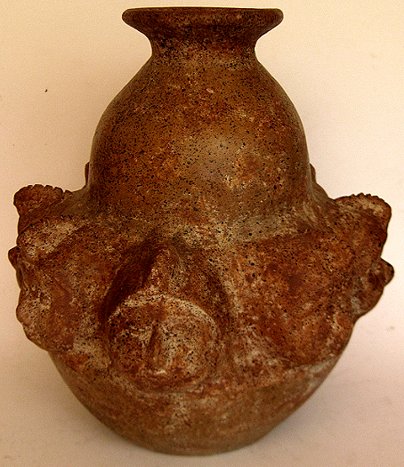 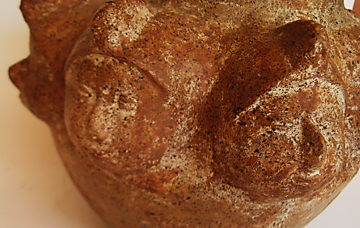

Figs. 1-2. AM,S-Ecuador-Chorrera culture-Vessel with Eight Anthropomorphic Heads-Terra Cotta-1200-300 BCE

**Case no.: 10**

**Accession Number: A567**

**Formal Label:**

AM,S-Ecuador-Chorrera culture-Vessel with Eight Anthropomorphic Heads-Terra Cotta-1200-300 BCE

**Display Description:**

This Chorrera vessel with eight (what appear to be) trophy heads protruding from the shoulder, each wearing ridged and serrated caps. The body is burnished red. This ceramic dates to c. 1200 BCE.

**LC Classification:**

**Date or Time Horizon:** 1200-300 BCE

**Geographical Area:**

**Map:**

**GPS coordinates:**

**Cultural Affiliation:**

**Media:**

**Dimensions:**

**Weight:**

**Condition:**

**Provenance:**

**Discussion:**

* The Late Formative Chorrera culture was one of the most widespread cultures in what is now the southern coast of Ecuador (Guayas, Manabí, and Esmeraldas provinces) and the Guayas River basin and its tributaries providing the Chorrera with riverine transportation and resources.

**References:**

Zeidler, J. A. "The Ecuadorian Formative." Helaine Silverman and William H. Isbell, eds. [Handbook of South American Archaeology.](https://books.google.com/books?id=yZr-lxQgJiAC&pg=PA468&lpg=PA468&dq=Chorrera+culture&source=bl&ots=o69xkt-d6T&sig=8VN6DiHUGedhc2F3UbSeSlxpz6o&hl=en&ei=8N7mTdXeHYfZiAKA6MiUDA&sa=X&oi=book_result&ct=result&resnum=10&ved=0CE8Q6AEwCQ#v=onepage&q=Chorrera%20culture&f=false) New York: Springer, 2008.